Let’s say you are the CEO of ABC Sports, which began its corporate life making footballs. It now has a leading brand in this product line. A few years ago, the management decided to leverage their strengths in the football business to enter footwear. The experiment has not been deemed successful, as your shareholders kindly pointed out to you during the most recent annual shareholder meeting. You are thinking of getting out of the footwear business and of refocusing on making footballs. Should you exit the footwear business and if so, in what manner?

Divestiture refers to the process of reducing the portfolio of the businesses a firm owns. It is one of the two important ways in which a corporation reduces its scope. The other is outsourcing (the subject of the next section). Divestiture occurs when the firm reduces the number of businesses it is active in by completely pulling out of the value chain and ceasing to offer the products from that value chain to the relevant customers. Consider ABC Sports, which is active in two businesses: footballs and footwear. If ABC Sports decides to divest the footwear business, this implies that it will no longer offer footwear. Alternatively, it may decide to outsource the manufacturing of the footwear, while still designing them and distributing them. The difference can be visualized as in Figure 8.1.

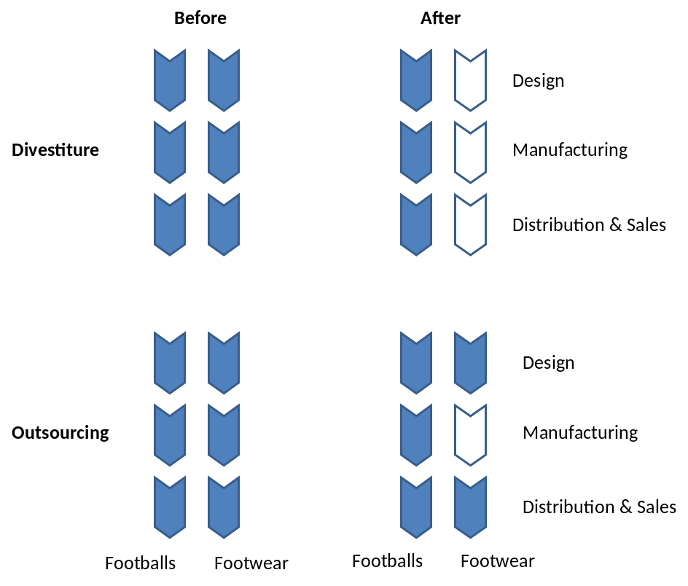
Figure 8.1 The difference between divestiture and outsourcing

The two basic modes of divestiture are sell-offs and spin-offs. In a sell-off, the divested business is sold to another company. When the other company uses significant amount of debt to finance its purchase, the transaction is called a Leveraged Buy-Out or LBO. A special case of this is when the incumbent management of a business unit takes over the ownership of the business (again typically using debt finance); this is called a Management Buy-Out or MBO. In a spin-off, the shares of the divested business B are distributed to the shareholders (of the parent A) and business B is listed on the capital market. Thus, the shareholders can choose whether they want to hold both shares or sell their stakes in B. The parent A may also choose to hold some residual stake in B. This can be a tax free event, if the parent divests a minimum threshold of shares. In contrast, the corporate parent is liable to capital gains tax in the event of a sell-off.

Two other modes of divestitures are equity carve outs and split-ups. In an equity carve out, the parent sells a fraction of B’s stock to the general public and keeps the rest. This is also called a partial IPO (initial public offering). Typically, parents keep initially around 80% of B’s shares. As such, they keep control, can consolidate earnings of business B with the parent’s other business, and avoid paying taxes on the money raised from the sale of shares (taxes are due if the fraction sold is above a threshold). Under a split-up, shares are created in the underlying businesses, while those in the former parent are discontinued. In Table 8.1, we summarize the differences between these modes of divestiture. In Figure 8.1, we highlight the ownership differences.

Table 8.1: Modes of divestiture
 | Sell-off | Spin-off | Equity carve-out | Split-up
Ownership passes to | Other company | Existing shareholders | Public | Existing shareholders and sometimes public
Generates cash | Yes | No | Yes | Yes if through equity carve outs. No if through spin-offs.
Parent remains in control | No | No | Generally  (in the short term) | Parent ceases to exist
Tax free event | No | Yes, if % shares divested above threshold | Yes, if % shares IPO’d less than threshold | Yes

It is only in the case of an equity carve out that the parent firms continues to control and exert influence on the business. Yet, within a few years of an equity carve out, the vast majority of parents will have reduced their stake to only a minority or no stake at all by selling more to the general public, by distributing shares to the parent’s shareholders (spin-off), or by selling to another company (sell-off). This raises an interesting question: If equity carve outs are temporary, why go through the trouble of doing one instead of opting directly for say a spin-off or sell-off? Staged transactions can offer certain benefits. A spin-off preceded by an equity carve-out generates cash whereas one without does not. This is handy for cash constrained companies. A sell-off preceded by an equity carve-out establishes a market price that companies can use in their negotiation for the sale of the business. This is useful when there is uncertainty about the value of the business.

In the remainder of this section we will focus on sell-offs and spin-offs. Split-ups are typically achieved through spin-offs and carve-outs, and carve-outs often end up as sell-offs and spin-offs.

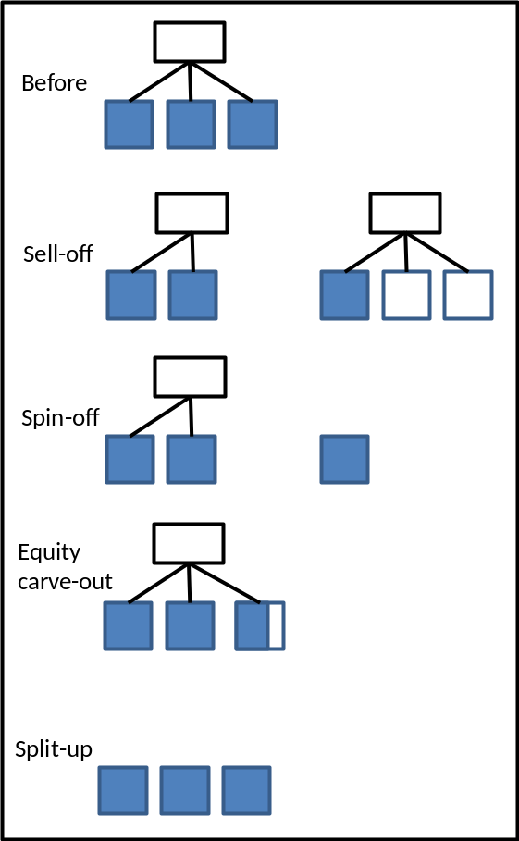
Figure 8.1: Ownership after divestiture

The divestiture decision
Let us say your corporate portfolio comprises businesses A and B. Whether you should keep or get rid of business B in the portfolio is the divestiture decision (see box 8.1).

Box 8.1 The Divestiture Test
The divestiture test can be written as:
V[A] + D_{m}[B] > V[AB]
V[AB] is the net present value of businesses A and B when they are jointly owned, as in the status quo. V[A] is the standalone value of business A after divesting business B. D_{m}[B] is the value from divesting business B for the original shareholders of the parent under divestiture mode m, either sell-off or spin-off. The key to operationalizing this test is estimating the NPV of businesses A and B when separately owned.

Divestiture mode (m) | D_{m}[B]
Sell-off | The price for which business B is sold to another company.
Spin-off | The value of business B as an independent, divested unit.

From the divestiture test it follows that a corporate parent should divest for one or both of the following reasons:

- Failing the synergy test
In the absence of synergies, divestiture is a good option. Assuming D_{m}[B] ≥ V[B] (i.e., for a sell-off, the price of selling a business is at least the stand-alone value of that business; for a spin-off, D_{m}[B] is the stand-alone value of that business), then a failure to pass the synergy test is sufficient to pass the divestiture test. The synergy test fails if separately operating two businesses is at least as good as jointly operating them (i.e., V(A) + V(B) ≥ V(AB)). For instance, there are no benefits from collaboration and each business would be better off making their own, independent decisions. The synergy test also fails if there are negative synergies. For instance, business B supplies business A and business B has difficulty attracting other customers as long as it is jointly operating with business A. Thus, failing the synergy test is grounds for a divestiture. It goes without saying that before proceeding to divest, we should also look at the possibility and feasibility of taking measures that will ensure we pass the synergy test, such as restructuring, reengineering and synergy projects.

- Another corporate parent is a better owner
If business B is better off with a different corporate parent than the current one, then it’s time to divest business B. This might be the case even if business B is performing well and is benefiting from the presence of business A. Thus, it is not necessary to fail the synergy test; even if the synergy test is passed (i.e., V(AB) > V(A) + V(B)), as long as you can get a really good price for business B (i.e., D[B] >> V[B]) then you should still divest. This might happen for instance if some other corporate parent has even stronger synergies with B than you do (or thinks that they do). This is one of the reasons an active policy of looking for divestiture opportunities is sensible.

 | Synergy test:  Pass | Synergy test:  Fail
Is there a better parent? Yes | Situation 1:  Sell-off | Situation 4:  Sell-off (if high premium or low taxes) or  Spin-off (if low fees)
Is there a better parent?  No | Situation 2:  Keep in portfolio (if full ownership is best),  Equity carve-out (if partial ownership is best), or  Spin-off (if no ownership is best). | Situation 3:  Spin-off
Figure 8.2: Chosing a divestiture mode

Whether the divestiture test is passed in one or both ways noted above has implications for the mode of divestiture. The joint implications are laid out in Figure 8.2. Suppose the synergy test is passed. If there is a better parent (situation 1), i.e., the other parent can pay more for the business than that what it is worth to you, then a sell-off is an attractive option. If there is no better parent (situation 2), this leaves several alternatives for how best to exploit synergies. Section 5 uses equity levels to distinguish governance structures, e.g., non-equity alliance, equity alliance, and full ownership. If full ownership is best to exploit synergies, then keeping the business in the portfolio is preferred. If partial ownership reduces the governance costs, then an equity carve-out can be considered. If no ownership allows synergies to be exploited at the lowest cost, then a spin-off should be considered.

Suppose the synergy test is failed; then we have effectively ruled out the option of keeping the business in the portfolio, and we must still decide between spin-off and sell-out. If there is no better parent (situation 3), then the option is clear: a spin-off. The case where you fail the synergy test and believe you can realize a gain from sale to another parent is an interesting one (situation 4). You should consider a sell-off, especially ifthe other parent is willing to pay a high premium compared to what the business is worth to you. However, capital gains are typically taxed. So companies may still choose a spin-off, possibly preceded by an equity carve-out. The choice between a sell-off and a spin-off will depend on considerations such as the expected valuation in each mode, the applicable tax rate, and underwriting fees (for the equity carve-out), see FAQ 7.

Basic facts about divestitures
The basic facts about divestiture to emerge from existing research relate to two areas:
1. When does a divestiture occur?
a) Unrelated diversification – Companies that are most diversified are more likely to divest a business, and they are most likely to divest the business that is unrelated to their other businesses. It could be that synergies are fewer (e.g. jointly operating value chains does not create value) or harder to exploit (e.g. top management time is limited).
b) Poor operating performance – Companies that perform poorly (e.g. low earnings) are more likely to divest a business, and they are most likely to divest the business that does worst.
c) Poor stock market performance – A company with a substantial diversification discount is more likely to divest, i.e. if it trades at a discount relative to non-diversified companies (see the Sum-Of-The-Parts analysis in Section 1 and also Section 4 on diversification). Such a discount arises if shareholders and analysts have difficulty in valuing the different businesses or appreciating the synergies between them (e.g. when the company has an unusual mix of businesses). Analysts are typically organized by industry making it harder for them to appreciate value creating opportunities that span multiple industries. After a divestiture, the company might be easier to value (but possibly at the loss of synergy exploitation).
d) External pressure – Activist investors often demand a divestiture, especially if a company is diversified into unrelated businesses, or has poor operating or stock market performance. Thus, external pressure amplifies the preceding conditions.
e) New CEO – Divestitures often coincide with the appointment of a new CEO. A divestiture can be a transformative change for a company and a new person may find it easier to take and implement such a decision than a CEO who has been in the job for many years.

Other important, but somewhat idiosyncratic reasons for divestiture include tax advantages, or anti-trust requirements following a merger to avoid excessive concentration of markets.

2. What is the outcome of a divestiture?
The consequence of a divestiture for the divesting parent is typically good for market returns. On average, a corporate parent that divests a business increases shareholder value. When measured in terms of a change in share price, this amounts to a low single digit increase (typically around 2%) for the divesting parent. Likewise, accounting measures such ROA, ROS, and earnings also improve for the parent.

Note that these findings do not however mean that a corporate parent should divest all its business, or that a strategy of divestiture will benefit every corporation that attempts it. This is because these results are mostly from a non-random sample of divested units-—corporate parents divests precisely those businesses for which it makes sense and hold on to those for which it is better that they stay in the corporation.

Somewhat surprisingly, spin-offs and carve-outs seem to do better than sell-offs in terms of value creation for the parent. One interpretation is that the destroying stand-alone value is more of a problem (and therefore unleashes more value when solved) than missing out on the additional value a better parent can create. Alternatively, it could be that this reflects a sequential process. First there is a partial IPO and then a sell-off so that the market reactions to an IPO may already include expectations about a subsequent sell-off.

Application: ABC Sports
Lets say that you are appointed the CEO of ABC Sports, whose problem was described in the opening paragraph of this section. You notice that various stakeholders are increasingly asking why ABC Sports entered footwear, and why it should continue to operate in that business. The more vocal critics ask for the footwear business to be divested. How would you reach a decision?

Step 1: The synergy test
The first step is to understand whether the footwear business is generating any synergies with the football business. (Note: we focus on operational syenrgies; you may also want to check for financial synergies). The following two thought experiments may help. First, imagine that starting today, the two businesses would be moved into separate ownership and would operated compeletely independently, with no communication or exchange of any kind between the two. How would the value of the busineses be affected? If there are indeed synergies between the two businesses, then the effect of such a spearation should be an adverse one. Second, imagine that the ownership of the businesses would still be separated, but the business would be allowed to collaborate. In other words, if there are synergies, would those be best exploited under separate or common ownership?

To make sure that you are considering all the possible ways in which synergies might exist between the businesses, you may find it useful to use the 4C’s approach outlined in Section 2. Recall from Section 2 that operational synergies come in four types: Consolidiation, Combination, Customization, and Connection. Further, these operational synergies derive from the value chain (and its underlying resources). So you could begin by drawing the value chain of the footwear business and that of the football business to make an assessment of the presence or absence of these different types of synergies.

You could also get some benchmarking data to compare how your footwear business is doing compared to other stand-alone footwear businesses or those that are part of a larger corporate portfolio. But please note that you may still be passing the synergy test between football and footwear businesses even if the footwear business is doing poorly compared to its standalone peers.

If at the end of this exercise, if you conclude that significant synergies DO exist between the businesses and those are hard to extract without (partial) ownership, then we have ruled out one option: spin-off. This is becaue a stand-alone valuation for the business cannot exceed what it is worth to you if there are synergies. You must still decide whether to keep footwear in your portfolio, or whether you can find a better corporate parent. If on the other hand you are NOT convinced that any synergies exist, then you have ruled out the option of keeping footwear in the portfolio: you must then decide between spin-off and sell-off. In other words, whether or not you pass the synergy test, you must consider the option of finding a better corporate parent.

Step 2: Finding a better corporate parent
Next , you should analyze whether other corporations are better corporate parents. You should distinguish between the following types of corporate parents:
- Synergistic buyers: Corporate parents active in the footwear business, or those who are not in footwear but who may see synergies with their existing businesses.
- Financial buyers (with limited operating synergies) who may be primarily interested in the footwear business to improve its financing structure.

Note that these are two ideal types of buyers, and in reality some kinds of buyers will fall somewhere in between; Private equity firms for instance are sometimes seen as purely financial buyers, but this need not be true. To the extent they aim to improve operations of their acquired companies by applying superior management skills, or by linking to the operations of other portfolio companies, then they are also synergistic buyers. You may also consider dividing up the business into pieces that are more likely to find better corporate parents. For instance there may be different takers for the manufaturing asssets and for the brand and distribution assets of the footwear business.

With the help of your corporate development team, you can make a list of companies under each category. You could look at trade journals, or ask your investment bankers to quietly ask around and get a sense of what the market might be like. You could also look for private equity firms that have been active in the past in related sectors, and see if your footwear busines fits the profile of the kinds of deals they have done - in terms of the operational performance relative to peers, or financing structure, for instance. For the synergistic buyers, you could use the same kind of analysis you did in Step I, to see if their value chains would generate stronger synergies with your footwear business than you do between footballs and footwear. In particular, you should look closely at those potential buyers that are in the footwear business, as they may have significant Consolidation/Combination synergies with your footwear business.

At the end of this exercise, you must be able to answer the following question: is it likely that you can realize a valuation from these other buyers that will leave you with a gain if you were to sell your footwear business to them? What you do next depends on combing this information with the results of your synergy test in Step I, as shown in Figure 8.2.

Step 3: Implement
If the analysis leads to an indication that sell-off or spin-off is indeed appropriate for the Footwear division, then you now have a clear rationale for your decision. Consider also the possible dependencies between your retained business and the divested business particularly in the case of sell-off when you are still passing the synergy test - one of the units may still need to provide some inputs or services to the other. This is equivalent to realizing D_{m}[B] not at one time, but over a period of time in the divestiture test (see box 8.1). These should be contractually specified and agreed upon with the buyer, and possibile transactional hazards should be considered (see Section 3 and also Section 9 on outsourcing).

You will also need to prepare your Footwear (and indeed Football division) employees for the divestiture. The rationale for the divestiture, how it will ultimately create value for share-holders, and what guarantees you have obtained from the buyer about the care of your employees once transferred to them all need to be communicated clearly to the relevant consituencies.

If on the other hand, if you choose to retain Footwear in the portfolio, you now have a clear rationale for this - including a more detailed a statement of synergies than you probably started with, and a sense of how other corporate parents might value the business. Next time you are asked why the footwear business is part of ABC Sports, you know what to respond: because ABC Sports can create more value from the footwear business than if it were standalone, and no one else can replicate it!

<APPLICATION ENDS>

Common mistakes to avoid in divestiture
Be Proactive, not reactive – Divesting when you can, and not when you have to is usually preferable; distress sales rarely turn a profit. It’s hard to let go of businesses, and it is something that does not seem to come naturally to many corporate managers. Hence, for divestitures to happen management often seem to need to be pushed into action, e.g. by activist investors, bad performance, new incentive plans, or even replacement of the CEO. However, from the divestiture test, it is clear that divestitures might be sensible even if a business is doing well. In other words, a pro-active attitude is useful, which is at the core of what a corporate strategist as the manager of a portfolio of businesses must cultivate.

Consider the consequences for the retained organization – Sometimes divesting a business might still mean that your remaining business are dependent on them, or vice versa - for inputs (as in the case of outsourcing) or to share infrastructure. Think about how these dependencies will be managed once ownership changes hands. Transaction Service Agreements (TSA’s) are contractual means of recognizing such dependencies and stipulate how the buyer can continue to receive certain services from the seller for a period after the divestiture (and possibly the other way round). These should be part of the divestiture negotiations in the case of sell-offs, and may also influence the valuation of the assets. A more subtle form of dependency lies in the fact that your own employees will evaluate you as an employer based on how the divested employees fare in their new parent corporation. A transparent and fair process for transitioning employees to the new parent is therefore not just ethically important but it is also good business sense.

Frequently Asked Questions
Q1: Another corporate parent wants to buy one of my businesses. We think the other parent is a better owner, but we can’t agree on a price. What should we do?
Here it appears that both sides see benefits from a deal. One possibility is to do a partial IPO (i.e. equity carve out), followed by a sell-off. The market price after the IPO then becomes a reference price for the negotiation. This is especially useful when it is difficult to value a business (e.g. uncertainty about future growth rates, intangible assets).

Q2: I understand the importance of identifying the best corporate parent for divestiture decisions. Is this also relevant for the diversification decision when buying a company in a business in which you are currently not active?
Yes and no. When you buy a company, it’s important to understand if you can create more value than the current owner and other bidders, i.e. if you are a better parent. If you cannot create more value, you are unlikely to end up with the target company and if you do, you probably will have overpaid.

However, what matters is that you’re a better parent than the companies involved (target, bidders, potential bidders), but not necessarily the best parent if the better parent is unaware of the target opportunity. In that case, you can go ahead buy the target and then try to sell on to the best parent (per the divestiture test).

Q3: Can a sum of the parts valuation of my multi-business firm help me with divestiture decisions?
Recall that a sum of the parts valuation using multiples from comparable stand-alone businesses makes two critical assumptions. First that the comparable businesses are truly comparable and second that the profits of your divisions will remain the same even if unlocked from your structure. If these two assumptions are valid, then the sum of the parts valuation can tell us is the portfolio is indeed worth more than the sum of the parts- i.e. if HQ is creating some value by controlling the businesses in the portfolio. If it is not, then we may conclude that a split-up is worth considering, but it is not possible to know which particular business should be divested. Of course a split-up and spin-off are the same if there are only two businesses in the portfolio.

Q4: What can a CEO do so that the market gets the company’s synergy story?
Complicated or unusual portfolios of businesses are hard to understand for outsiders, which may lead to low analysts’ valuations. This is a problem for a CEO, especially if his corporate strategy is based on synergies about which he needs to convince the market. A drastic solution is to divest a business. Not only is this decision hard to reverse, but also a CEO may sacrifice synergies that are hard to explain but valuable. There are other alternatives. Most importantly, be transparent and provide sufficient information to the investment community. Even though the financial reporting requirements on the individual businesses are lower than for the corporation as whole, having reliable data about the businesses is crucial for understanding how the portfolio could be worth more than the sum of the individual businesses. Make sure that analysts follow the company. Furthermore, an investor relations department is essential. If the market “does not get it” but the CEO is convinced about the synergies, then he can put his money where his mouth is: buy the undervalued shares of the company.

Q5: I have heard about a split-off and spin-out. What are these?
A split-off is like a spin-off: a business is divested as a standalone unit and no cash is generate. In a spin-off, shareholders get shares in the divested business and keep their shares in the parent (though they are free to sell either share). In a split-off, shareholders have to choose whether they keep their shares in the parent or instead take shares in the divested business.

A spin-out is a company founded by a former employee of the parent, possibly with financial or technical support of the parent. This is not a divestiture because the business did not exist before. Confusingly, the term spin-out is sometimes used to mean spin-off.

Q7. When the synergy test is failed and there is a better corporate parent, how do I choose between a sell-off and a spin-off?
Suppose we had to choose between a sell-off (subject to corporate tax) and a spin-off preceded by an equity carve out (let’s assume this is tax free) for the a business, the choice would rest on on a comparison of the following two numbers:
- Value from IPO/spin-off: (expected share price * shares sold at IPO – underwriting fees) + (remaining shares * expected share price).
- Value from sell-off: expected sale price of company – [(expected sale price – document value)*(tax rate)].
The acceptable Expected Sale Price from sell-off should be such that the second number is at least as large as the first.

Q8. The presence or absence of bargains features in the diversification decision (Section 4). Where does it feature in the divestiture decision?
A bargain implies a good deal for one party and a bad deal for the other. For diversification we are interested in buying a business for less than what it is worth. For divestitures we are interested in selling a business for more than what it is worth. Hence, when considering bids of other corporate parents, some may overpay, which is bad for them but good for your corporation.

Academic background
For a theoretical discussion of the reasons for divestiture:
Hoskisson, R. E., & Turk, T. A. (1990). Corporate restructuring: Governance and control limits of the internal capital market. Academy of Management Review, 15(3), 459-477.

For a matched sample comparison of firms that divest and others that do not, to understand what might be driving divestiture behavior, see:
Berger, P. G., & Ofek, E. (1999). Causes and effects of corporate refocusing programs. Review of Financial Studies, 12(2). 311-345.

For meta-analyses of the empirical literature on divestitures, see:
Brauer, M. (2006). What have we acquired and what should we acquire in divestiture research? A review and research agenda. Journal of Management, 32(6), 751-785.
Lee, D., & Madhaven, R. (2010). Divestiture and firm performance: A meta-analysis. Journal of Management, 36(6), 1345-1371.

For recent studies on divestitures, see:
Feldman, E. R. (2014). Legacy divestitures: Motives and implications. Organization Science, 25(3), 815-832.
Feldman, E. R., Amit, R., & Villalonga, B. (2014). Corporate divestitures and family control. Strategic Management Journal.
Moschieri, C. (2011). The implementation and structuring of divestitures: The unit's perspective. Strategic Management Journal, 32(4), 368-401.

For the rationale behind equity carve outs, see
Allen J. W. & McConnell J. J. (1998) Equity carve-outs and managerial discretion, Journal of Finance, 53(1): 163-186.
Vijh A. M. (2002) The Positive Announcement‐Period Returns of Equity Carve-outs: Asymmetric Information or Divestiture Gains?, Journal of Business, 75(1): 153-190.

